SUMMARY

USC ID/s:
1248363133 – Anjali Mehta
3908543660 – Siqi Dong
7184608860 – Dean Woods
2919603029 – Varun Kapoor
8142329307 – Tianming Ji

Datapoints

M+N | Time in MS (Basic) | Time in MS (Efficient) | Memory in KB (Basic) | Memory in KB (Efficient)
16 | 0.06689453125 | 0.07605552673 | 18528 | 19216
64 | 0.2451171875 | 0.538110733 | 18336 | 18448
128 | 0.8930664063 | 1.437902451 | 18352 | 18400
256 | 3.135009766 | 6.530761719 | 18976 | 17792
384 | 8.321044922 | 11.82174683 | 19664 | 17680
512 | 14.91210938 | 25.30264854 | 19648 | 18448
768 | 36.37011719 | 46.23293877 | 20976 | 18208
1024 | 52.17822266 | 86.52091026 | 21840 | 18000
1280 | 85.66113281 | 135.3108883 | 23248 | 18528
1536 | 112.0031738 | 183.2647324 | 24736 | 18240
2048 | 215.2919922 | 350.6522179 | 29120 | 18784
2560 | 340.5209961 | 530.8549404 | 33152 | 18304
3072 | 493.7492676 | 783.6890221 | 39168 | 18560
3584 | 673.5979004 | 1067.532063 | 38176 | 18576
3968 | 828.5388184 | 1338.90605 | 42944 | 18512

Insights

Graph1 – Memory vs Problem Size (M+N)

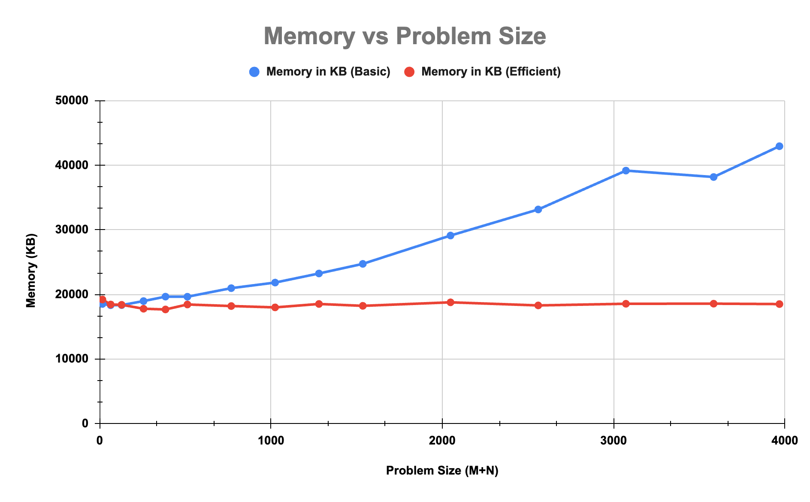

Nature of the Graph (Logarithmic/ Linear/ Polynomial/ Exponential)
Basic: Polynomial
Efficient: Linear

Explanation:
The memory usage of the basic algorithm increases polynomially because it constructs a full dynamic programming table of size m*n. As the expanded input sequences grow, the DP matrix grows quadratically, which leads to a steady and increasingly steep rise in memory consumption. In the graph, this appears as the upward-curving blue line, which starts around 18,000 KB and grows to roughly 43,000 KB for the largest problem sizes.

In contrast, the memory-efficient algorithm drastically reduces memory requirements by storing only a small portion of the DP table, typically one or two rows at a time, while recomputing subproblems as needed. This reduces the space complexity to O(m + n). As a result, its memory usage remains almost constant, fluctuating only slightly around 18,000 KB regardless of input size. This behavior is reflected in the flat red line on the graph.

Overall, the graph illustrates the clear scalability advantage of the efficient algorithm, while the basic version’s memory usage grows rapidly with problem size, the efficient version maintains stable and predictable memory requirements, making it far more suitable for large-scale problems.

Graph2 – Time vs Problem Size (M+N)

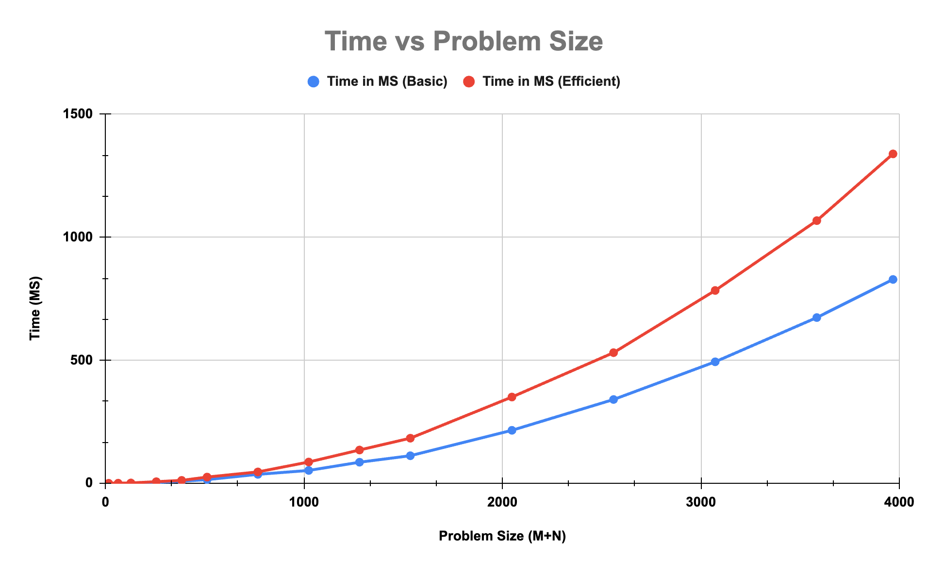

Nature of the Graph (Logarithmic/ Linear/ Polynomial/ Exponential)
Basic: Polynomial
Efficient: Polynomial

Explanation:
Both the basic and efficient algorithms exhibit polynomial growth in runtime as the problem size increases, which is expected because dynamic programming for sequence alignment requires evaluating an m * n grid of subproblems, giving it a time complexity of O(mn). The basic algorithm computes the dynamic programming table once, filling all entries in a direct and systematic manner, so its runtime increases steadily with input size but stays lower than that of the efficient algorithm.

In contrast, the efficient algorithm, while significantly better in memory usage, incurs additional time overhead due to its divide-and-conquer strategy, which requires repeatedly recomputing portions of the DP table and executing multiple recursive calls. This overhead becomes increasingly impactful for larger inputs, causing the red curve to rise more sharply and eventually surpass the blue curve.

Overall, the graph illustrates a clear trade-off between time and space: the basic algorithm runs faster but consumes substantially more memory, whereas the efficient algorithm dramatically reduces memory usage at the cost of increased runtime.

Contribution
Equal Contribution

